**MANUAL OSTEOPATHY HEALTH INFORMATION FORM**

**Fiona Dorey: DOMP, R.Kin, BHK-MS(Hons)**

Please provide us with the following medical information so that we can customize your therapy. **_________________________________________________________________________________________________________**

Today’s Date: _____________________________ (Month, Day, Year)

Patient Name: _____________________________ Date of Birth (M,D,Y): ____________ Gender: ____________ Home Address: ______________________________________________________________________

Cell Phone Number: _______________________________ Other phone number: ___________________

Email: _________________________________________. Occupation: ________________________________________________

Emergency contact: ___________________________ Phone: __________________________________

How did you hear about me? ____________________________________________________________

What brings you in today?

________________________________________________________________________________________________________________________________________________________________________________________________________________________________________________________________________________________________

When did this problem start?_______________________________________________

Does it radiate? YES or NO To where?______________________________

Does it interfere with: Daily Routine, Sleep, Work? Other interferences not listed please explain if applicable___________________________________________________

Have you seen any other professionals for this? If so who and when?

________________________________________________________________________

What makes it better? __________________________________________________

What makes it worse?__________________________________________________

Check symptoms that may apply: Aching___ Dull _____ Burning ____ Tingles ____ Pain ______ Tight ____ Numbness____ Sharp _____ Shooting _____Hot_____ Cold________

Describe other symptoms not listed above_____________________________________

When your symptoms are at their worst from 1-10 (10 being the worst) please indicate on scale 1--2--3—4—5—6—7—8—9—10

What is your pain right now from 1 -10: 1—2—3—4—5—6—7—8—9—10

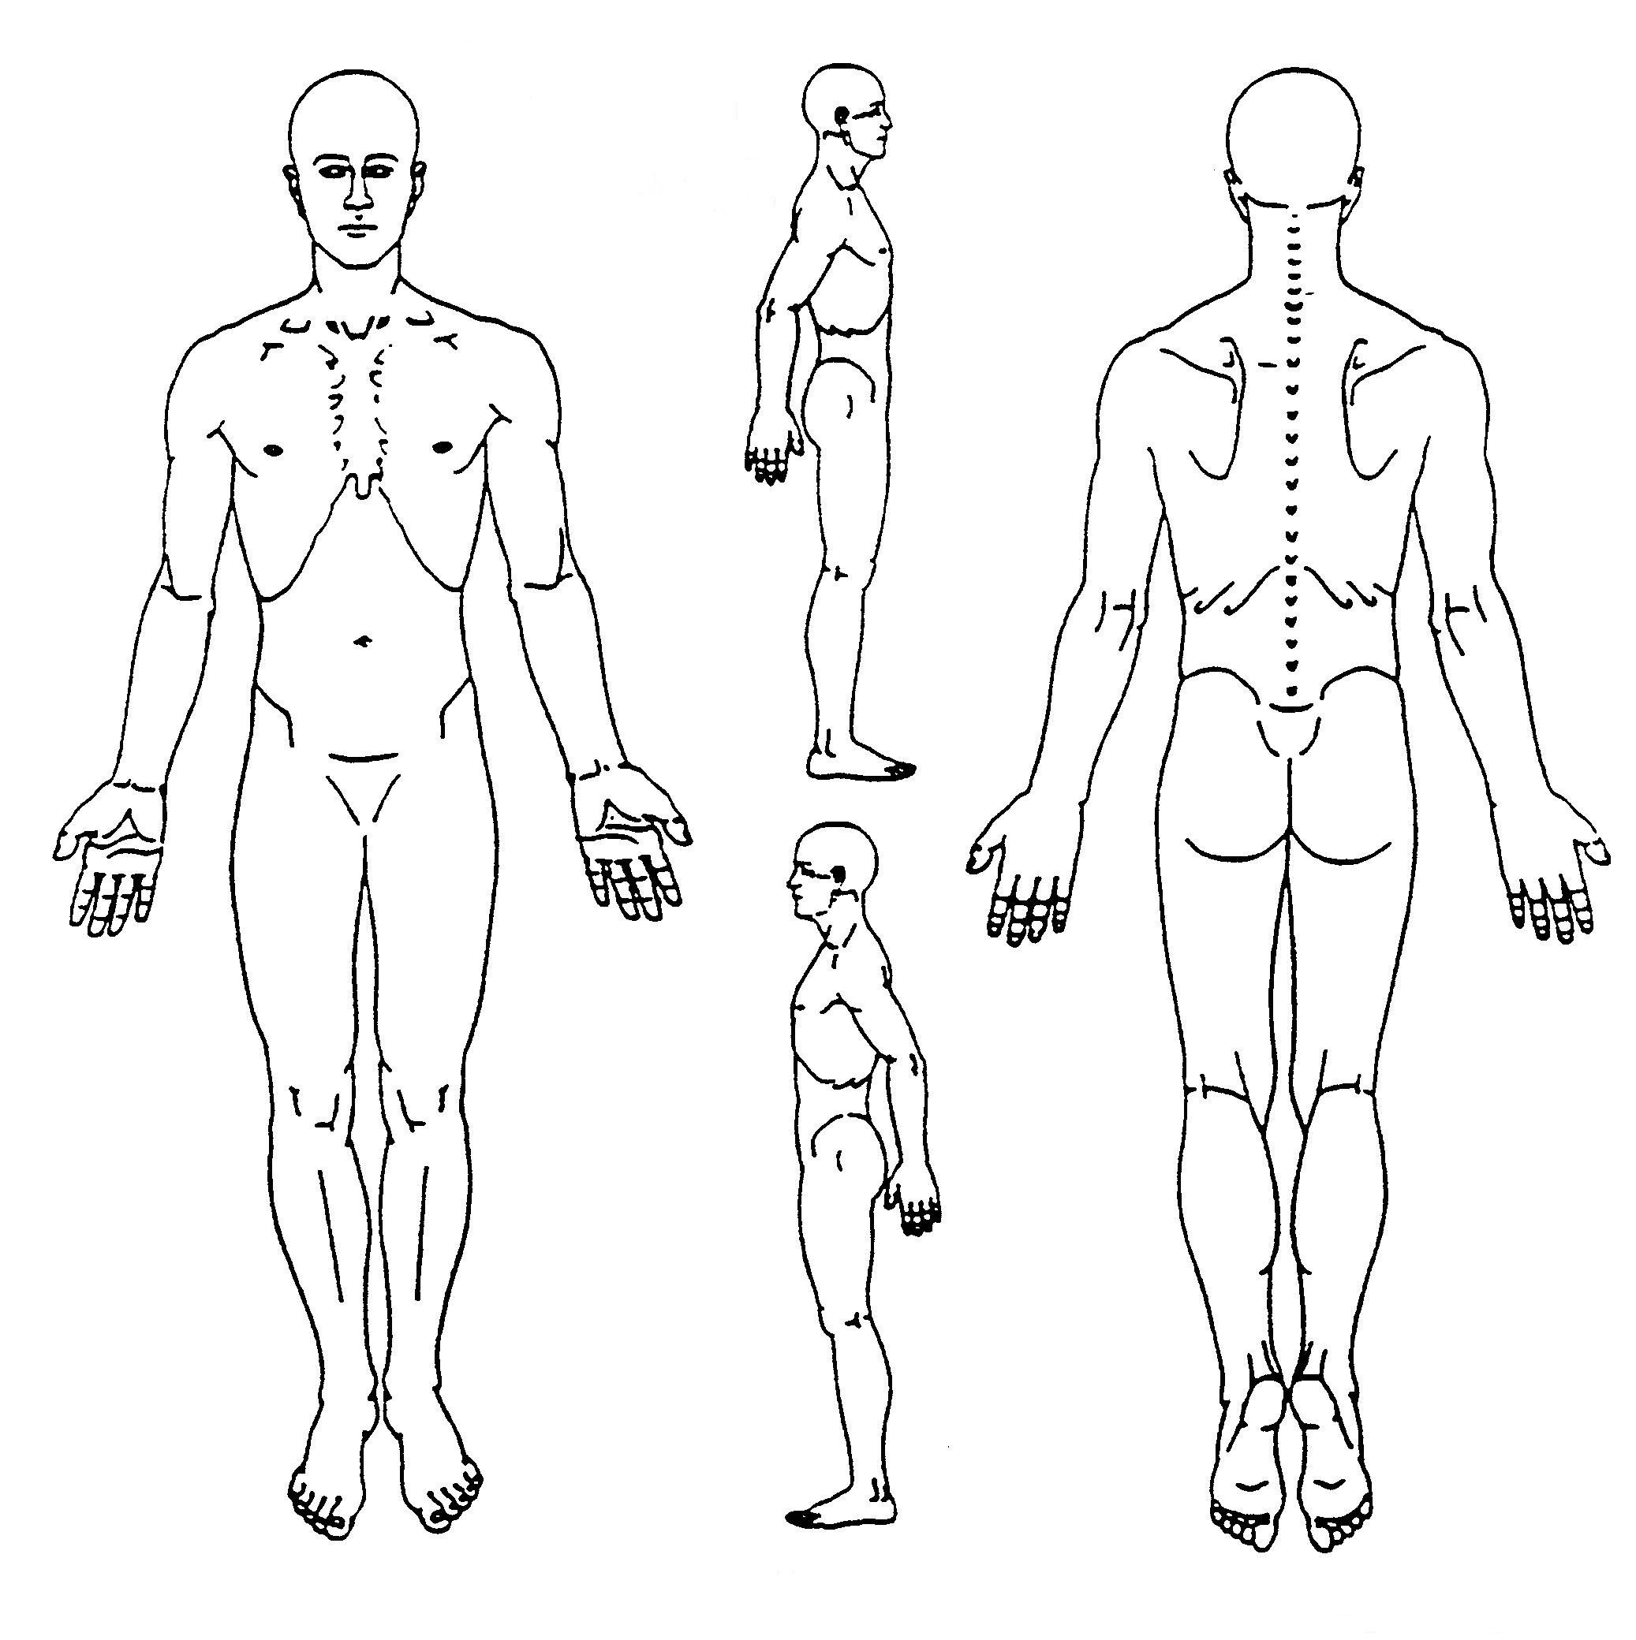***Please circle areas of concern on diagram.***

Motor Vehicle Accidents and Dates of Accident/s (Within the last 2 years) _______________________________________________________________________________________________________________________

Recent Surgery/ Surgeries and Dates (Within the last 2 years)

_______________________________________________________________________________________________________________________

***Please circle any illness or functional disorders that you have had, and explain the treatment received:***

|  |  |  |
| --- | --- | --- |
|  | **Type of Illness** | **Injury/ Illness Explanation** |
| **Cardiovascular** | High BP  Low BP  Heart Disease/Attacks  Stroke  Varicose Veins  Other |  |
| **Musculoskeletal** | Neck  Back (mid/low)  Shoulders  Arms  Elbows  Hands  Hips  Legs  Knees  Feet  TMJ  Head(aches, migraines)  Other |  |
| **Gastrointestinal** | GERD ( Heart Burn)  Gastritis  Dyspepsia (nausea, bloating)  Constipation  IBS  Liver/ Gallblader  Other |  |
| **Respiratory** | Asthama  Bronchitis  COPD  Emphysema  Cystic Fibrosis  Other |  |
| **Genitourinary** | Kidney  Bladder  Chronic/ Infrequent Urination |  |
| **Woman Specific Questions** | Pregnant Y/N  Due Date__________  How Many Pregnancy’s? ____  How Many Children? ______  OBGYN / Professionals Name _____________________  Any Irregular Symptoms with Menstrual Cycle (including aches and pains)________________________________ |  |
| **Other** | Arthritis (OA/RA)  Skin Disorders🡪 Eczema  Infections  Vision Problems  Ear Problems  Nose/Throat  Dizziness  Nervous System Disorders  Psychiatric Disorders  Cancer  Diabetes Type 1 or Type 2  Thyroid  Epilepsy  Allergies? _________________  Frequent Colds? Y/N  Autism |  |

**Current Medications/ Supplements:**

1)_________________________________________

2)_________________________________________

3)_______________________________________

4)_______________________________________

5)_______________________________________

**Any Other General Health Concerns not listed above**

Signature ______________________________________ Date ___________________